Low Level Design

MASK WEAR DETECTION

|  |  |
| --- | --- |
| Written By | SOMAY |
| Document Version | 0.3 |
| Last Revised Date | 02 – SEP -2021 |

**Document Control**

### Change Record:

|  |  |  |  |
| --- | --- | --- | --- |
| **Version** | **Date** | **Author** | **Comments** |
| 0.1 | 1 – SEP -  2021 | SOMAY | Introduction & Architecture defined |
| 0.2 | 1 – SEP -  2021 | SOMAY | Architecture & Architecture Description appended and updated |
| 0.3 | 2 – SEP -  2021 | SOMAY | Unit Test Cases defined and appended |
|  |  |  |  |
|  |  |  |  |
|  |  |  |  |

### Reviews:

|  |  |  |  |
| --- | --- | --- | --- |
| **Version** | **Date** | **Reviewer** | **Comments** |
| 0.2 | 2 – SEP-  2021 | SOMAY | Document Content , Version Control and Unit Test Cases to be added |

### Approval Status:

|  |  |  |  |  |
| --- | --- | --- | --- | --- |
| **Version** | **Review**  **Date** | **Reviewed By** | **Approved By** | **Comments** |
|  |  |  |  |  |

Contents

1. Introduction 1
   1. What is Low-Level design document? 1
   2. Scope 1
2. Architecture 2
3. Architecture Description 3
   1. Data Description 3
   2. Web Scrapping 3
   3. Data Transformation 3
   4. Data Insertion into Database 3
   5. Export Data from Database 3
   6. Data Pre-processing 3
   7. Data Clustering 3
   8. Model Building 4
   9. Data from User 4
   10. Data Validation 4
   11. User Data Inserting into Database 4
   12. Data Clustering 4
   13. Model Call for Specific Cluster 4
   14. Recipe Recommendation & Saving Output in Database 4
   15. Deployment 4
4. Unit Test Cases 5

# Introduction

## What is Low-Level design document?

The goal of LLD or a low-level design document (LLDD) is to give the internal logical design of the actual program code for Food Recommendation System. LLD describes the class diagrams with the methods and relations between classes and program specs. It describes the modules so that the programmer can directly code the program from the document.

## Scope

Low-level design (LLD) is a component-level design process that follows a step-by-

step [refinement](https://en.wikipedia.org/wiki/Refinement_(computing)) process. This process can be used for designing data structures, required software architecture, source code and ultimately, performance algorithms. Overall, the data organization may be defined during requirement analysis and then refined during data design work

# Architecture

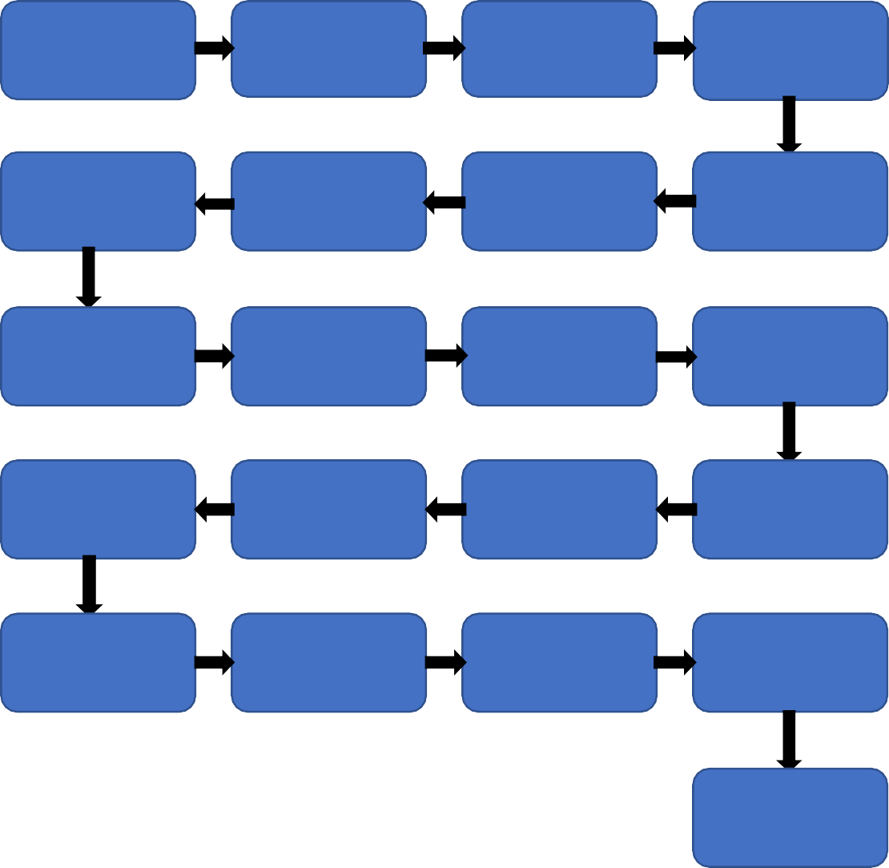

Start

Data for

Recommendation

Web

Scrapping

Data

Transformation

NLP Techniques

Data

Preprocessing

Export Data

from Database

Data Insertion

Into Databases

Data Clustering

Model Building

Cloud Setup

Pushing app to

cloud

Data Insertion

into Database

Data Validation

Data from User

Application

Start

Data Clustering

Model Call for

Specific Cluster

Recipe

Recommendation

Saving Output

at Database

End

# Architecture Description

## Data Description

I collect the dataset from google we have a dataset of two category one is person image in mask and other categories without mask images we have total 1376 images in the data set.

## Web Scrapping

In order to create a more complete data collection we will need some more datasets which will contain more accuracy of images.

## Data Transformation

In the Transformation Process, we will convert our original dataset which is in png or jpg Format. And will merge it with the Scrapped dataset.

## Data Insertion into Database

1. Database Creation and connection - Create a database with name passed. If the database is already created, open the connection to the database.
2. Table creation in the database.
3. Insertion of files in the table

## Export Data from Database

Data Export from Database - The data in a stored database is exported as a CSV file to be used for Data Pre-processing and Model Training.

## Data Pre-processing

Data Pre-processing steps we could use are Null value handling, stop words removal, punctuation removal, Tokenization, Lemmatization, TFIDF, Imbalanced data set handling, Handling columns with standard deviation zero or below a threshold, etc.

## Data Clustering

K-Means algorithm will be used to create clusters in the pre-processed data. The optimum number of clusters is selected by plotting the elbow plot. The idea behind clustering is to implement different algorithms to train data in different clusters. The K-means model is trained over preprocessed data and the model is saved for further use in prediction

## Model Building

After clusters are created, we will find the best model for each cluster. For each cluster, algorithms will be passed with the best parameters derived from Grid-Search. We will calculate the AUC scores for models and select the model with the best score. Similarly, the models will be selected for each cluster. All the models for every cluster will be saved for use in Recommendation.

## Data from User

Here we will collect physiological data from user such as user height and weight, heart rate, burned calories, daily physical activity level; as well as information directly provided by the user such as daily food intake

## Data Validation

Here Data Validation will be done, given by the user

## User Data Inserting into Database

Collecting the data from the user and storing it into the database. The database can be either MySQL or Mongo DB.

## Data Clustering

The model created during training will be loaded, and clusters for the user data will be predicted.

## Model Call for Specific Cluster

Based on the cluster number, the respective model will be loaded and will be used to predict/Recommend the data for that cluster.

## Saving Output in Database

After calling model Recipe/Output will be mask or not , this output will be saved in Database and it will beused to show the same Output if other users provide the same data.

## Deployment

We will be deploying the model to AWS.

This is a workflow diagram for the mask wear detection.

# Unit Test Cases

